**Week6**

**PORTFOLIO**

**Assessment Weightage & Type:**

**60% Portfolio Coursework**

**Year:2024**

* Student Name: Pratha Sharma
* UWE ID: 24030176
* Module code: **UFCFL1-15-0**
* Level: **Level 3)**
* Faculty: **Faculty of Internet & Technology**
* Department: **FET Department of Computer Science & Creative**

**Technology**

Week 6:

**Exercise-1**

Design a web page using four different image files ‘image1.jpg’, ‘image2.jpg’,

‘image3.jpg’ and ‘image4.png’ according to the following specifications.

• Use a border 5px for ‘image1.jpg’.

• Resize the width and height of ‘image2.jpg’ 100 pixels each. Use anchor tag on

this image and open original image.

• Align ‘image3.jpg” to either left or right side

• Leave space of 50px horizontally and vertically in ‘image4.png’

• align the text with respect to the images so as to obtain the appropriate output

Code:

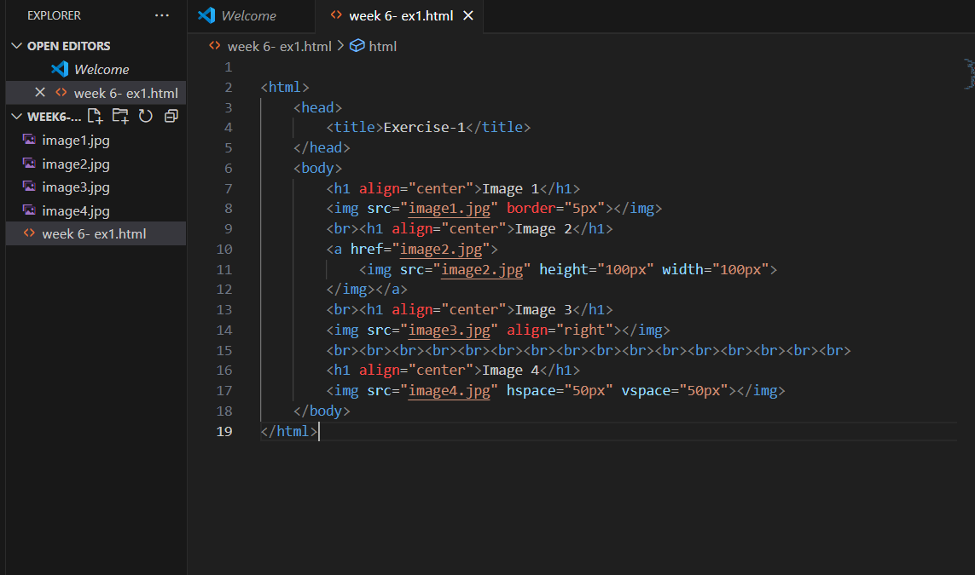

**Exercise 2**

Create a document home.html with two links to an external document (about.html). The

first link should lead to the beginning of the about.html. The second link should lead to a

particular section Contact information in the about.html.

home.html should also contain a google logo of size 400px X 100px. On clicking this

image, it should redirect to www.google.com

[Note: Make your own design and content]

Code:

Home.html

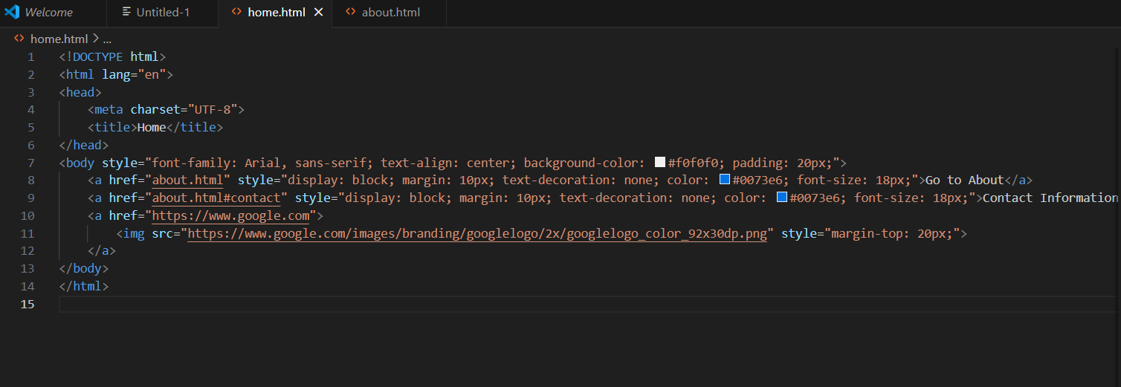

About.html

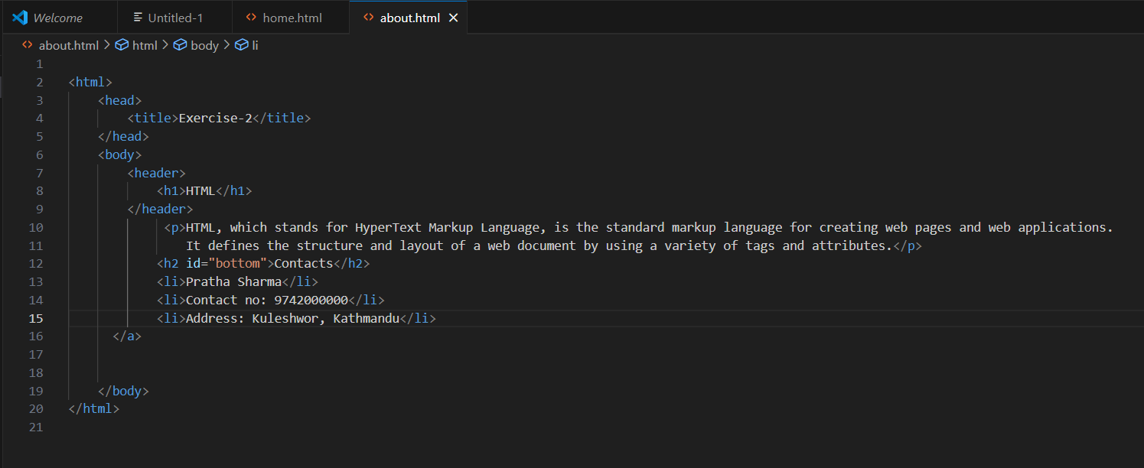

Website:

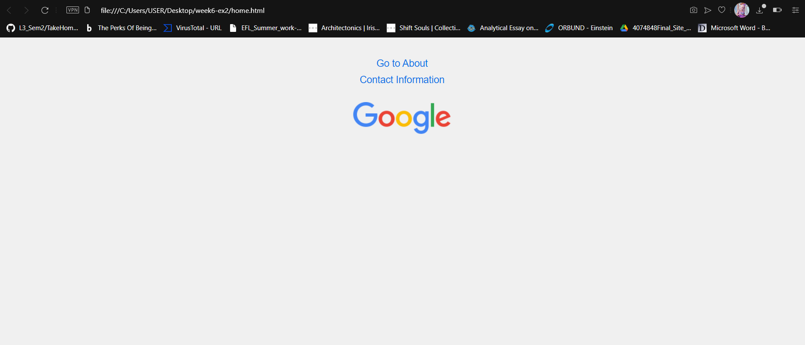

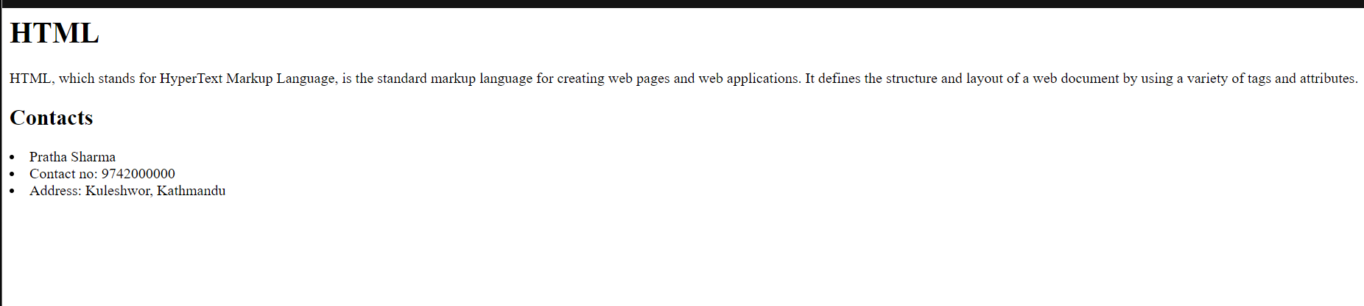

**Exercise 3**

Create a Web page giving the following Bus details.

Place a border for the table and use cell padding to present the cell data with clarity.

Align the table in the center of the screen. Use a caption saying ‘Bus Sewa Time Table

and Fare List’.

Code:

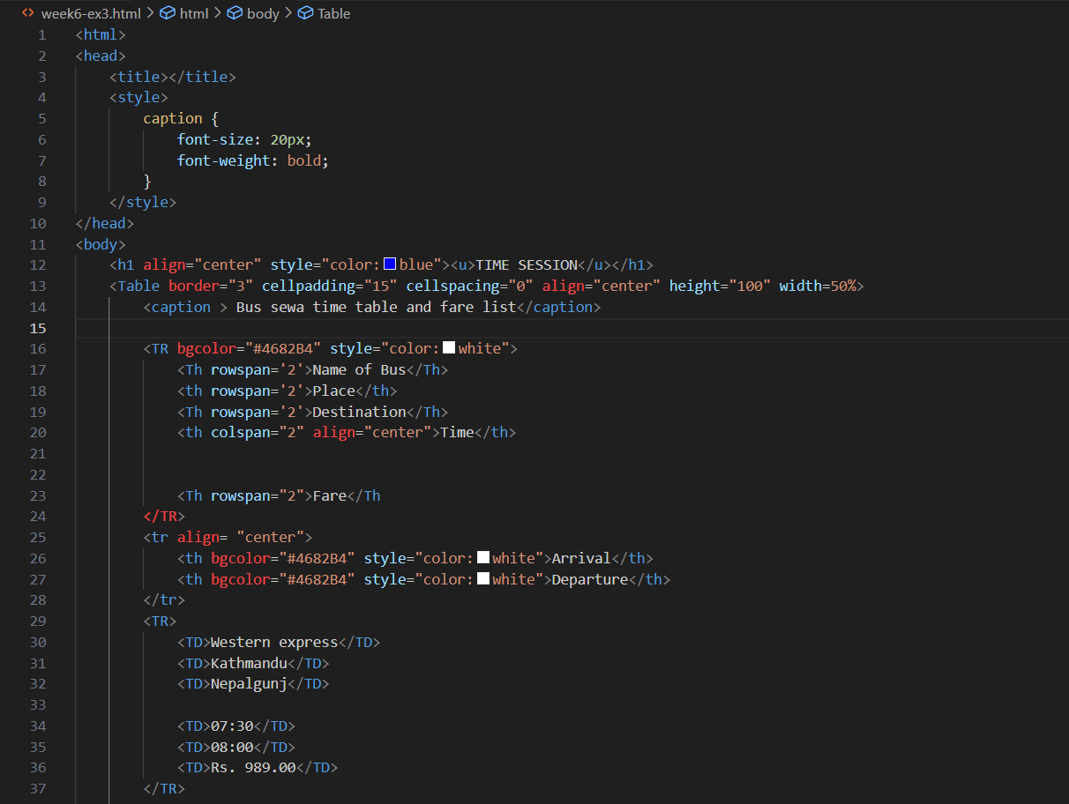

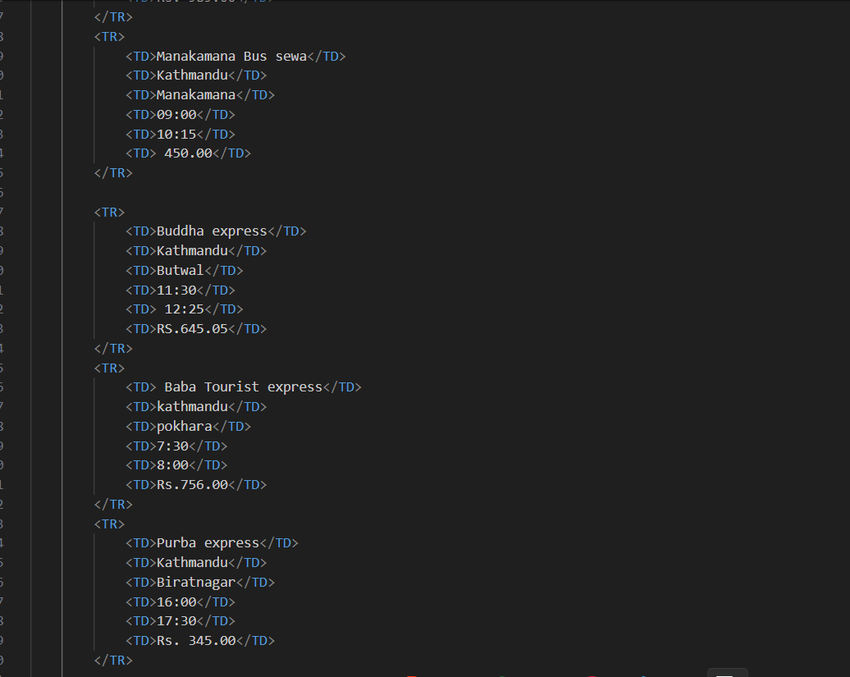

Website:

